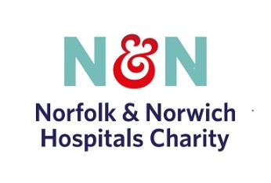

DONATION AND GIFT AID FORM
Title | First Name |  |  |  |  | Surname
Address
Postcode |  |  | Tel. |  | Mobile |  | Email

Keeping in Touch
We would love to keep you up to day on our hospital charity news but due to changes in legislation we need you to opt-in to confirm your consent. Please can you confirm your preferred contact details above and indicate mailing preferences (please tick all that apply)

We do not share any data with any third party

Postal Opt In □ I am happy to be contacted about your work and appeals via post
Telephone Opt In □ I am happy to be contacted about your work and appeals via telephone
Email Opt In □ I am happy to be contacted about your work and appeals via email

Details of Your Donation
If you would like your donation to benefit a certain ward or department please specify ……………………………………………………………
Amount: Cash/Cheque:

Increase The Value of Your Donations WIth Gift Aid
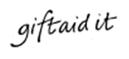 |  |  |  | The Gift Aid Scheme increases the value of your donation at no extra cost to you.  For every £1 you give, the government will add 25p.  All you need to do is complete your name and address details and sign below.  All your gifts to NNUH Charity in future will also be topped up with Gift Aid.  Higher rate taxpayers can claim tax relief for the higher rate tax element of the donation - please contact your Inland Revenue Office for details.  □ I am a UK taxpayer. Please treat all donations I make or have made to Norfolk & Norwich University Hospital NHS Foundation Trust Charitable Fund (1048170) for the past 4 years as Gift Aid donations until further notice.
Gift Aid Declaration
I am a UK taxpayer and understand that if I pay less Income Tax and/or Capital Gains tax than the amount of Gift Aid claimed on all my donations in that tax year, it is my responsibility to pay any difference and that I can cancel this Gift Aid declaration at any time by writing to the Charity
Signature |  |  |  |  |  |  |  |  | Date

Thank you for Supporting the N&N Hospitals CHARITY (1048170)
Fundraising 6th Floor 20 Rouen Road Norwich Norfolk NR1 1QQ T: 01603 287107 E: fundraising@nnuh.nhs.uk
INTERNAL USE
RECEIPT NUMBER ………………………………………………FUNDRAISING TO THANK ………………Y / N ………………

